DIGIT 2023 Paper Title
Indicate Submission Type: Completed Research Paper, Research-in-Progress Paper

Single author’s/panelist’s name
Affiliation
Address
e-mail

or

First author’s/panelist’s name  Affiliation  Address  e-mail | Second author’s/panelist’s name  Affiliation  Address  e-mail
Third author’s/panelist’s name
Affiliation
Address
e-mail

or

First author’s/panelist’s name  Affiliation  Address  e-mail | Second author’s/panelist’s name  Affiliation  Address  e-mail
Third author’s/panelist’s name  Affiliation  Address  e-mail | Fourth author’s/panelist’s name  Affiliation  Address  e-mail

[The organizing committee will remove all authors’ details before sending out the manuscripts for reviews.]
Abstract
Include your abstract here followed by the keywords as indicated. The abstract should not be longer than 250 words.
Keywords: Template, formats, instructions, length, conference publications

DIGIT 2023 Paper Title
Indicate Submission Type: Completed Research Paper, Research-in-Progress Paper

Introduction
We ask that authors follow these basic guidelines when submitting to DIGIT. In essence, you should format your paper exactly like this document. The easiest way to use this template is to replace the placeholder content with your own material. The template file contains specially formatted styles (e.g., Normal, Heading, Bullet, References, Title, Author, Affiliation) that are designed to reduce the work in formatting your final submission.

Page Size and Spacing
On each page, your material (not including the header and footer) should fit within a rectangle of 16.5 x 22.8 cm (6.5 x 9 in.), centered on a US letter page, beginning 1.27 cm (0.5 in.) from the top of the page. Please adhere to the US letter size only (in MS Word, you can check the page format in the menu: File --> Page Setup). If you cannot do so, please contact the review coordinator for assistance. All final publications will be formatted and displayed in US letter size. Right margins should be justified, not ragged. All margins must measure 1” (2.5 cm) around. Beware, especially when using this template on a Macintosh, Word may change these dimensions in unexpected ways.
Please ensure your manuscript complies with the following instructions:
- Line spacing should be single (exactly 1.0);
- Margins should be 1 inch (2.54 cm);
- Do not change character or word spacing;
- Please do not use double spaces between sentences – this is a tradition no longer necessary on modern word processors;
- Please do not edit the styles in this template;
- Please ensure all text is justified, not “ragged” ( = left-aligned).
Non-compliance of these instructions may lead to desk rejection of your paper.

Length
Papers, both complete research (16 pages) and research-in-progress (8 pages) submissions, must be single-spaced, include an abstract, and submitted in Microsoft Word format. These page limits are all-inclusive; they include the title page, body of the paper, figures, tables, references, and all appendices. A separate title page should include the paper title and the authors' names, affiliations, and e-mail addresses. The main body of the paper should have the title, but no author identification.

Title
Your paper’s title should be using the “Title” style in this template (which is configured as Georgia 20-point bold). Ensure proper capitalization within your title (i.e. “The Next Frontier of Information Systems” versus “the next frontier of Information systems.”
All proper nouns should be capitalized. Articles (the, a), coordinating conjunctions (and, but, or, for, nor, etc.) should not be capitalized, unless, of course, they are used as the first word in the title. Likewise for prepositions (on, at, to, from, by, etc.).

Normal or Body Text
Please use the “Normal” style for normal text – this style is configured as a 10-point Georgia font (similar to Times New Roman, but more easily read online) or, if it is unavailable, another proportional font with serifs, as close as possible in appearance to Times New Roman 10-point. Please use sans-serif or non-proportional fonts (such as Arial or Courier) only for special purposes, such as source code text (SpecialStyle). [References to Georgia font from this point forward should be interpreted as “Georgia or equivalent.”]

Sections
The heading of a section should be using the “Heading 1” style – configured as Georgia 13-point bold, left justified. Sections should not be numbered.

Subsections
Headings of subsections should be using the style “Heading 2” – configured as Georgia 11-point bold italics with initial letters capitalized. (Note: for sub-sections and sub-subsections, words like ‘the’, ‘of’, ‘a’, ‘an’ are not capitalized unless it is the first word of the heading.)

Sub-subsections
Headings for sub-subsections should be using “Heading 3” – configured as Georgia 10-point bold with initial letters capitalized. Please do not go any further into another layer/level.

Figures, Tables & Captions
Place figures and tables close to the relevant text (or where they are referenced in the text).
Captions should be using the “Caption” style – configured as Georgia 10-point bold. They should be numbered (e.g., “Table 1” or “Figure 2”), centered and placed beneath the figure or table. Please note that the words “Figure” and “Table” should be spelled out (e.g., “Figure” rather than “Fig.”) wherever they occur. The proceedings will be made available online, thus color figures are possible.

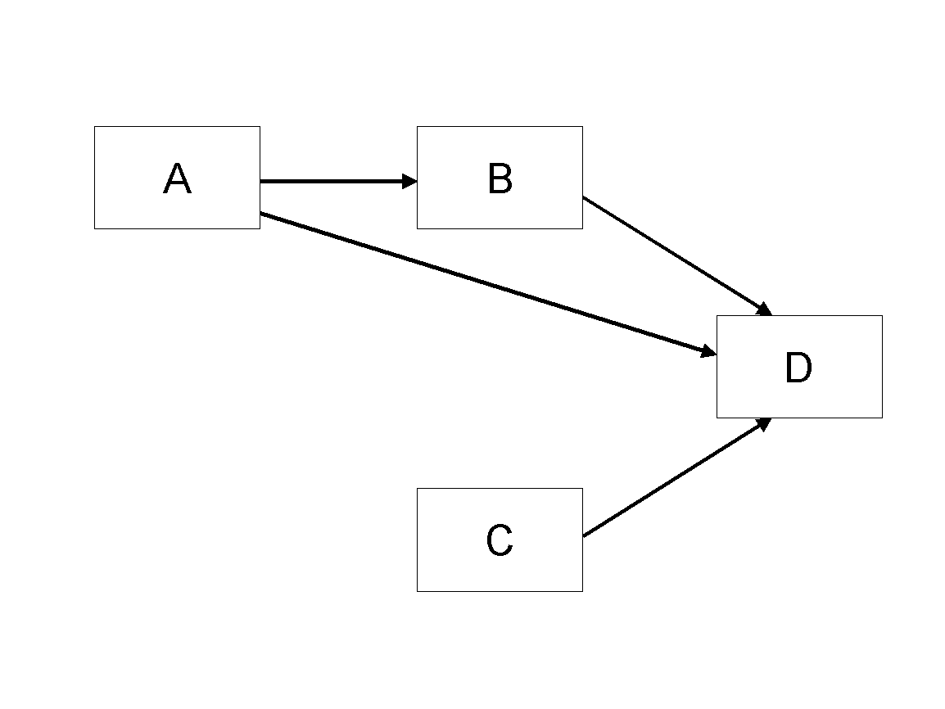
Figure 1. Modified Research Model

Table Style
Inserting a table in the text can work well. You may want to adjust the vertical spacing of the text in the tables. (In Word, use Format | Paragraph… and then the Line and Page Breaks tab. Generally, text in each field of a table will look better if it has equal amounts of spacing above and below it, as in Table 1.)
 | Treatment 1 | Treatment 2
Setting A | 125 | 95
Setting B | 85 | 102
Setting C | 98 | 85
Table 1. A Very Nice Table

Language, Style, and Content
With regard to spelling and punctuation, you may use any dialect of English (e.g., British, Canadian, US, etc.) provided this is done consistently. Hyphenation is optional. To ensure suitability for an international audience, please pay attention to the following:
- Write in a straightforward style.
- Try to avoid long or complex sentence structures.
- Briefly define or explain all technical terms that may be unfamiliar to readers.
- Explain all acronyms the first time they are used in your text – e.g., “primary care provider (PCP)”.
- Explain local references (e.g., not everyone knows all city names in a particular country).
- Be careful with the use of gender-specific pronouns (he, she) and other gendered words (chairman, manpower, man-months). Use inclusive language that is gender-neutral (e.g., they, s/he, chair, staff, staff-hours, person-years).

Acknowledgements (optional)
Please do not add acknowledgements to your original submission because it will help identify authors. Acknowledgements may be added later, if the paper is accepted.

References and Citations
References are to be formatted using the new MIS Quarterly style (http://www.misq.org/manuscript-guidelines under MISQ References Format). References must be complete, i.e., include, as appropriate, volume, number, month, publisher, city and state, editors, last name & initials of all authors, page numbers, etc. Your references should comprise only published materials accessible to the public. Proprietary information may not be cited. References should be ordered in alphabetic order.

References
Ackoff, R. L. 1961. "Management Misinformation Systems," Management Science (14:4), pp. 147-156.
Benbasat, I., and Zmud, R. W. 2003. “The Identity Crisis within the IS Discipline: Defining and Communicating the Discipline’s Core Properties,” MIS Quarterly (27:2), pp. 183-194.
Bonini, C. P. 1963. Simulation of Information and Decision Systems in the Firm, Englewood Cliffs, NJ: Prentice-Hall.
Broadbent, M., Weill, P., O’Brien, T., and Neo, B. S. 1996. “Firm Context and Patterns of IT Infrastructure Capability,” in Proceedings of the 14th International Conference on Information Systems, J. I. DeGross, S. Jarvenpaa, and A. Srinivasan (eds.), Cleveland, OH, pp. 174-194.
Carroll, J. 2005. “The Blacksburgh Electronic Village: A Study in Community Computing,” in Digitial Cities III: Information Technologies for Social Capital, P. van den Besselaar and S. Kiozumi (eds.), New York: Springer-Verlag, pp. 43-65.

